**BAHRIA UNIVERSITY, Karachi Campus)**

# Department of Software Engineering

# ASSIGNMENT # 02 – Fall 2022

|  |  |  |  |
| --- | --- | --- | --- |
| Course Title: **Software Construction** | |  | Course Code: **SEN-311** |
| Class: **BSE – 5(B)** | |  | Shift: **Morning** |
| Course Instructor: **Engr. Misbah Perveen** | |  |  |
| Max. Marks: **5.0 Marks** |

**Instructions:**

1. This is a Complex Engineering Problem Assignment.
2. Deadline for the submission of Assignment on is 14th DEC 2022.
3. Hardcopies of the Assignments will be submitted on the same day.
4. If you submit your assignment after the given deadline then 2 Marks will be deducted for the late submissions.

**Question No. 1: [CLO#02, 5.0 marks]**

Code refactoring techniques are applied to make the code better. Identify and apply refactoring techniques on the provided code of Trivia Game:

**Trivia Data Class:**

import java.util.ArrayList;

public class TriviaData

{

private ArrayList<TriviaQuestion> data;

public TriviaData()

{

data = new ArrayList<TriviaQuestion>();}

public void addQuestion(String q, String a, int v, int t)

{

TriviaQuestion question = new TriviaQuestion(q,a,v,t);

data.add(question);

}

public void showQuestion(int index)

{

TriviaQuestion q = data.get(index);

System.out.println("Question " + (index +1) + ". " + q.value + " points.");

if (q.type == TriviaQuestion.TRUEFALSE)

{

System.out.println(q.question);

System.out.println("Enter 'T' for true or 'F' for false.");

}

else if (q.type == TriviaQuestion.FREEFORM)

{

System.out.println(q.question);

}

}

public int numQuestions()

{

return data.size();

}

public TriviaQuestion getQuestion(int index)

{

return data.get(index);

}

}

**Trivia Question Class:**

public class TriviaQuestion

{

public static final int TRUEFALSE = 0;

public static final int FREEFORM = 1;

public String question;

public String answer;

public int value;

public int type;

public TriviaQuestion()

{

question = "";

answer = "";

value = 0;

type = FREEFORM;

}

public TriviaQuestion(String q, String a, int v, int t)

{

question = q;

answer = a;

value = v;

type = t;

}

}

**Trivia Game Class:**

import java.io.*;

import java.util.Scanner;

public class TriviaGame

{

public TriviaData questions; // Questions

public TriviaGame()

{

// Load questions

questions = new TriviaData();

questions.addQuestion("The possession of more than two sets of chromosomes is termed?",

"polyploidy", 3, TriviaQuestion.FREEFORM);

questions.addQuestion("Erling Kagge skiied into the north pole alone on January 7, 1993.",

"F", 1, TriviaQuestion.TRUEFALSE);

questions.addQuestion("1997 British band that produced 'Tub Thumper'",

"Chumbawumba", 2, TriviaQuestion.FREEFORM);

questions.addQuestion("I am the geometric figure most like a lost parrot",

"polygon", 2, TriviaQuestion.FREEFORM);

questions.addQuestion("Generics were introducted to Java starting at version 5.0.",

"T", 1, TriviaQuestion.TRUEFALSE);

}

// Main game loop

public static void main(String[] args)

{

int score = 0; // Overall score

int questionNum = 0; // Which question we're asking

TriviaGame game = new TriviaGame();

Scanner keyboard = new Scanner(System.in);

// Ask a question as long as we haven't asked them all

while (questionNum < game.questions.numQuestions())

{

// Show question

game.questions.showQuestion(questionNum);

// Get answer

String answer = keyboard.nextLine();

// Validate answer

TriviaQuestion q = game.questions.getQuestion(questionNum);

if (q.type == TriviaQuestion.TRUEFALSE)

{

if (answer.charAt(0) == q.answer.charAt(0))

{

System.out.println("That is correct! You get " + q.value + " points.");

score += q.value;

}

else

{

System.out.println("Wrong, the correct answer is " + q.answer);

}

}

else if (q.type == TriviaQuestion.FREEFORM)

{

if (answer.toLowerCase().equals(q.answer.toLowerCase()))

{

System.out.println("That is correct! You get " + q.value + " points.");

score += q.value;

}

else

{

System.out.println("Wrong, the correct answer is " + q.answer);

}

}

System.out.println("Your score is " + score);

questionNum++;

}

System.out.println("Game over! Thanks for playing!");

}

}

Code Refactoring is restructuring or rearranging code in a series of small, semantics-preserving transformations (i.e., the code keeps working) in order to make the code easier to maintain and modify.

Extract Method

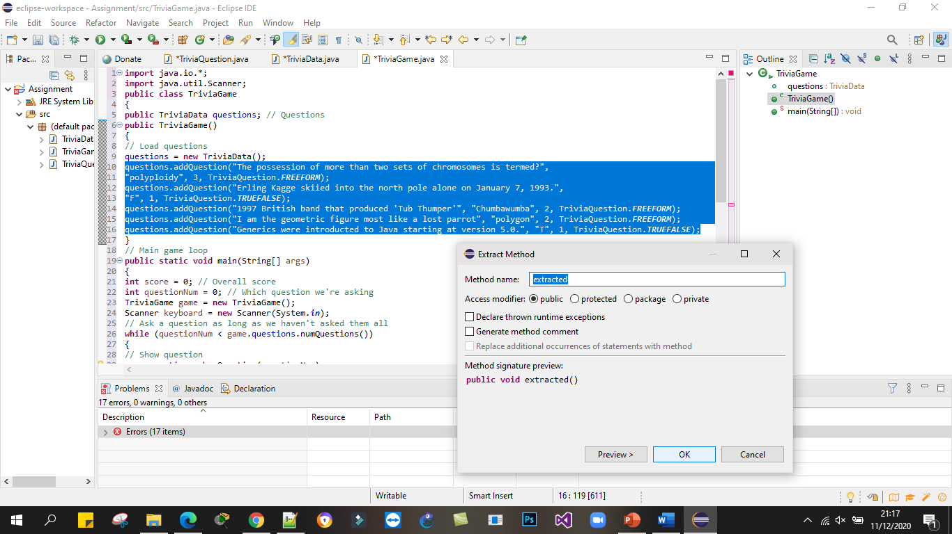

**After Refactoring**

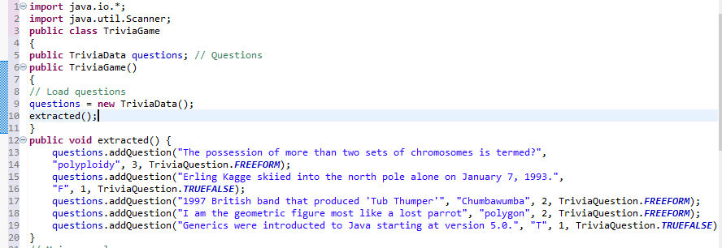

**Extract Class Trivia question**

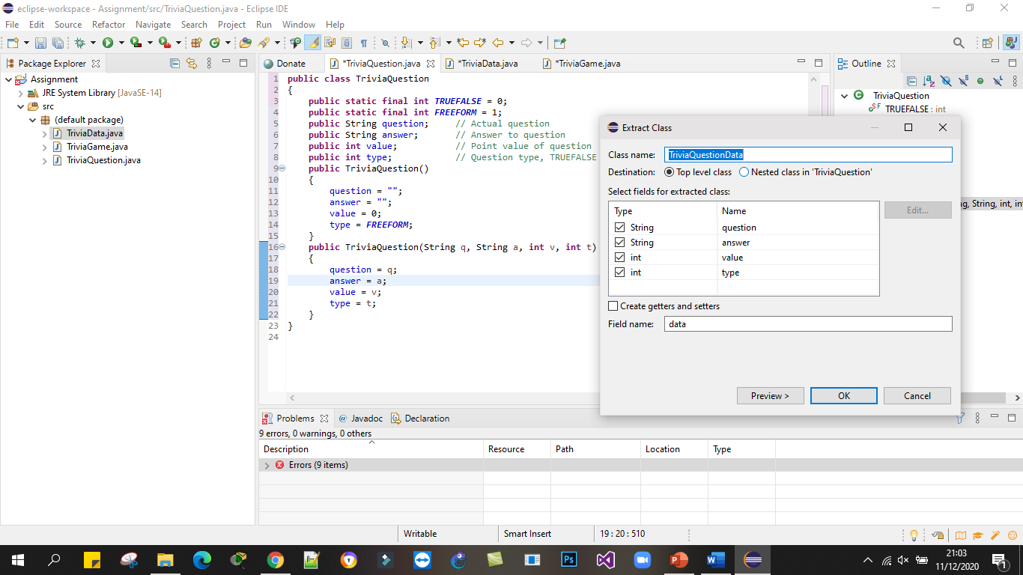

**public** **class** TriviaQuestion

{

**public** **static** **final** **int** ***TRUEFALSE*** = 0;

**public** **static** **final** **int** ***FREEFORM*** = 1;

**public** TriviaQuestionData data = **new** TriviaQuestionData();

**public** TriviaQuestion()

{

data.setQuestion("");

data.setAnswer("");

data.setValue(0);

***data***.setType(***FREEFORM***);

}

**public** TriviaQuestion(String q, String a, **int** v, **int** t)

{

data.setQuestion(q);

data.setAnswer(a);

data.setValue(v);

data.setType(t);

}

}

**public** **class** TriviaQuestionData {

**private** String question;

**private** String answer;

**private** **int** value;

**private** **int** type;

**public** TriviaQuestionData() {

}

**public** String getQuestion() {

**return** question;

}

**Method Rename**

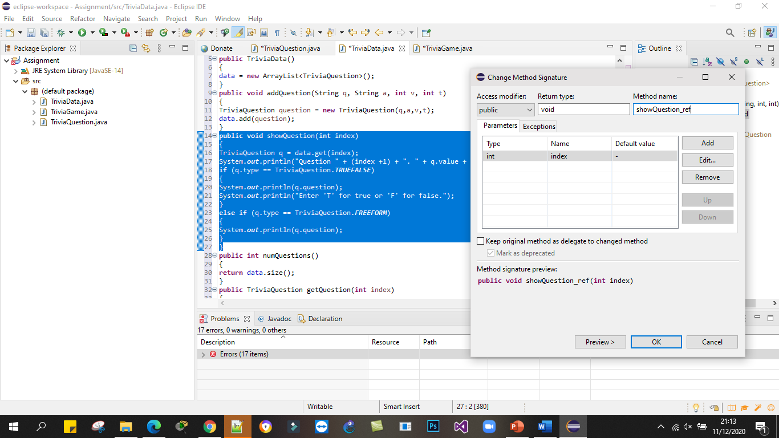

**public** **void** showQuestion_ref(**int** index)

{

TriviaQuestion q = data.get(index);

System.***out***.println("Question " + (index +1) + ". " + q.value + " points.");

**if** (q.type == TriviaQuestion.***TRUEFALSE***)

{

System.***out***.println(q.question);

System.***out***.println("Enter 'T' for true or 'F' for false.");

}

**else** **if** (q.type == TriviaQuestion.***FREEFORM***)

{

System.***out***.println(q.question);

}

}

**Extract Local Variable**

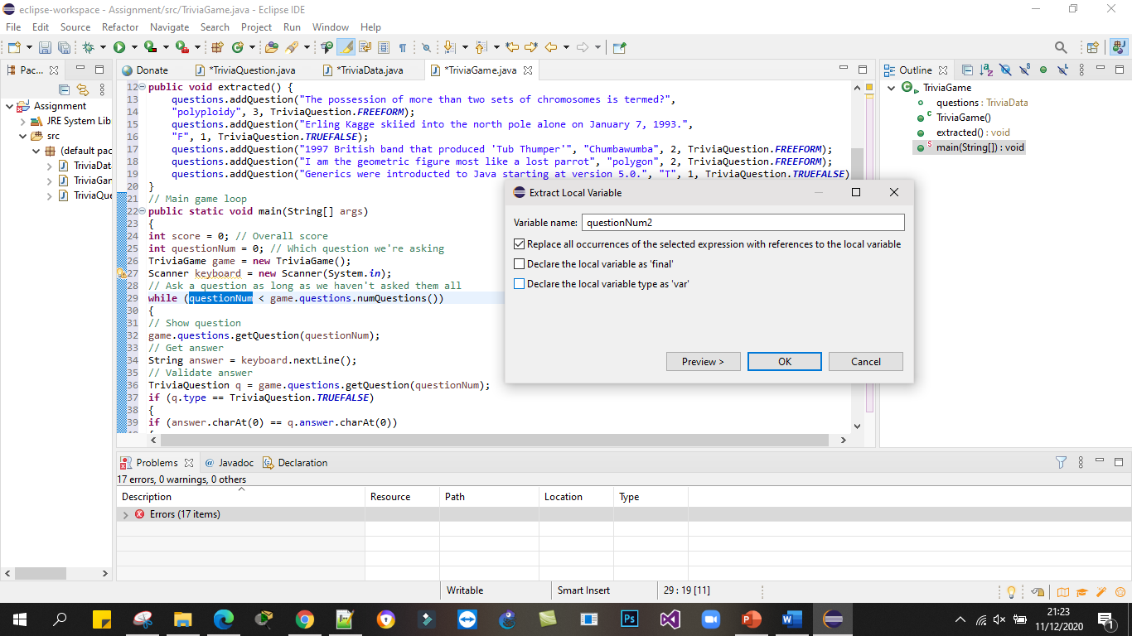

**After Refactoring**

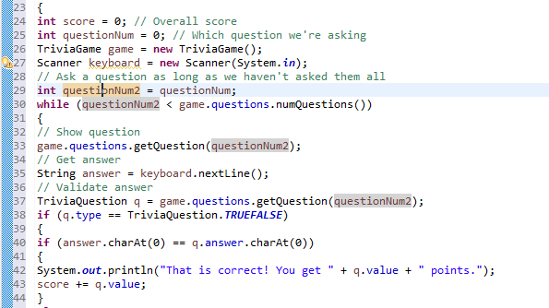

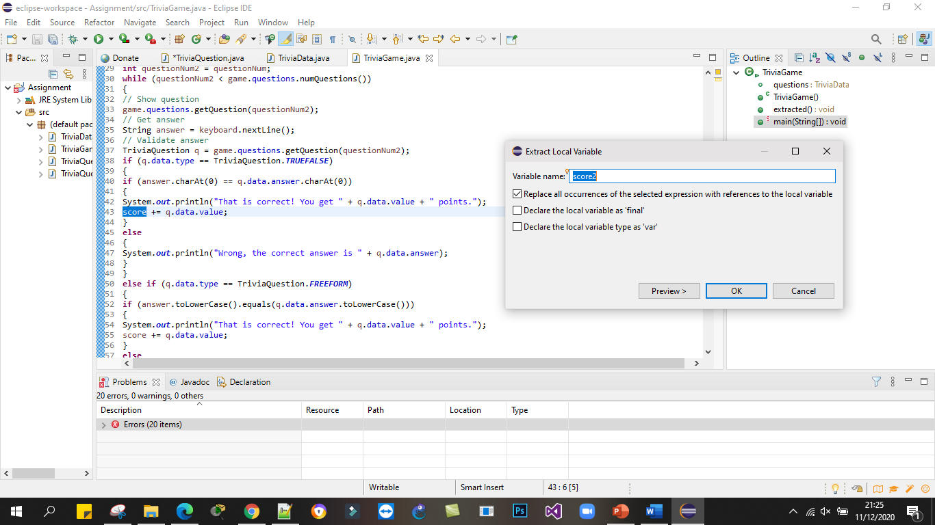

**After Refactoring**

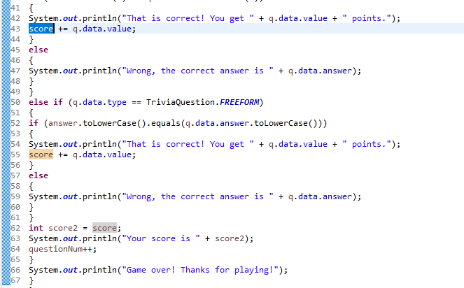

**Final Code (Class Trivia question)**

**public** **class** TriviaQuestion

{

**public** **static** **final** **int** ***TRUEFALSE*** = 0;

**public** **static** **final** **int** ***FREEFORM*** = 1;

**public** TriviaQuestionData data = **new** TriviaQuestionData();

**public** TriviaQuestion()

{

data.question = "";

data.answer = "";

data.value = 0;

data.type = ***FREEFORM***;

}

**public** TriviaQuestion(String q, String a, **int** v, **int** t)

{

data.question = q;

data.answer = a;

data.value = v;

data.type = t;

}

}

**Final Code (Class Trivia question data)**

**public** **class** TriviaQuestionData {

**public** String question;

**public** String answer;

**public** **int** value;

**public** **int** type;

**public** TriviaQuestionData() {

}

**public** String getQuestion() {

**return** question;

}

}

**Final Code (Class Trivia game)**

**import** java.io.*;

**import** java.util.Scanner;

**public** **class** TriviaGame

{

**public** TriviaData questions; // Questions

**public** TriviaGame()

{

// Load questions

questions = **new** TriviaData();

extracted();

}

**public** **void** extracted() {

questions.addQuestion("The possession of more than two sets of chromosomes is termed?",

"polyploidy", 3, TriviaQuestion.***FREEFORM***);

questions.addQuestion("Erling Kagge skiied into the north pole alone on January 7, 1993.",

"F", 1, TriviaQuestion.***TRUEFALSE***);

questions.addQuestion("1997 British band that produced 'Tub Thumper'", "Chumbawumba", 2, TriviaQuestion.***FREEFORM***);

questions.addQuestion("I am the geometric figure most like a lost parrot", "polygon", 2, TriviaQuestion.***FREEFORM***);

questions.addQuestion("Generics were introducted to Java starting at version 5.0.", "T", 1, TriviaQuestion.***TRUEFALSE***);

}

// Main game loop

**public** **static** **void** main(String[] args)

{

**int** score = 0; // Overall score

**int** questionNum = 0; // Which question we're asking

TriviaGame game = **new** TriviaGame();

Scanner keyboard = **new** Scanner(System.***in***);

// Ask a question as long as we haven't asked them all

**int** questionNum2 = questionNum;

**while** (questionNum2 < game.questions.numQuestions())

{

// Show question

game.questions.getQuestion(questionNum2);

// Get answer

String answer = keyboard.nextLine();

// Validate answer

TriviaQuestion q = game.questions.getQuestion(questionNum2);

**if** (q.data.type == TriviaQuestion.***TRUEFALSE***)

{

**if** (answer.charAt(0) == q.data.answer.charAt(0))

{

System.***out***.println("That is correct! You get " + q.data.value + " points.");

score += q.data.value;

}

**else**

{

System.***out***.println("Wrong, the correct answer is " + q.data.answer);

}

}

**else** **if** (q.data.type == TriviaQuestion.***FREEFORM***)

{

**if** (answer.toLowerCase().equals(q.data.answer.toLowerCase()))

{

System.***out***.println("That is correct! You get " + q.data.value + " points.");

score += q.data.value;

}

**else**

{

System.***out***.println("Wrong, the correct answer is " + q.data.answer);

}

}

**int** score2 = score;

System.***out***.println("Your score is " + score2);

questionNum++;

}

System.***out***.println("Game over! Thanks for playing!");

}

}

**Final Code (Class Trivia data)**

**import** java.util.ArrayList;

**public** **class** TriviaData

{

**private** ArrayList<TriviaQuestion> data;

**public** TriviaData()

{

data = **new** ArrayList<TriviaQuestion>();

}

**public** **void** addQuestion(String q, String a, **int** v, **int** t)

{

TriviaQuestion question = **new** TriviaQuestion(q,a,v,t);

data.add(question);

}

**public** **void** showQuestion_ref(**int** index)

{

TriviaQuestion q = data.get(index);

System.***out***.println("Question " + (index +1) + ". " + q.data.value + " points.");

**if** (q.data.type == TriviaQuestion.***TRUEFALSE***)

{

System.***out***.println(q.data.question);

System.***out***.println("Enter 'T' for true or 'F' for false.");

}

**else** **if** (q.data.type == TriviaQuestion.***FREEFORM***)

{

System.***out***.println(q.data.question);

}

}

**public** **int** numQuestions()

{

**return** data.size();

}

**public** TriviaQuestion getQuestion(**int** index)

{

**return** data.get(index);

}

}